**Need Changes in Admin panel**

1. Category Page of Admin panel—Please check current Eindia Admin Panel and make admin panel according to it, We have option in category block at current admin panel like content, display setting and Search Engine Optimization and products, but these things are missing in admin panel provide by you

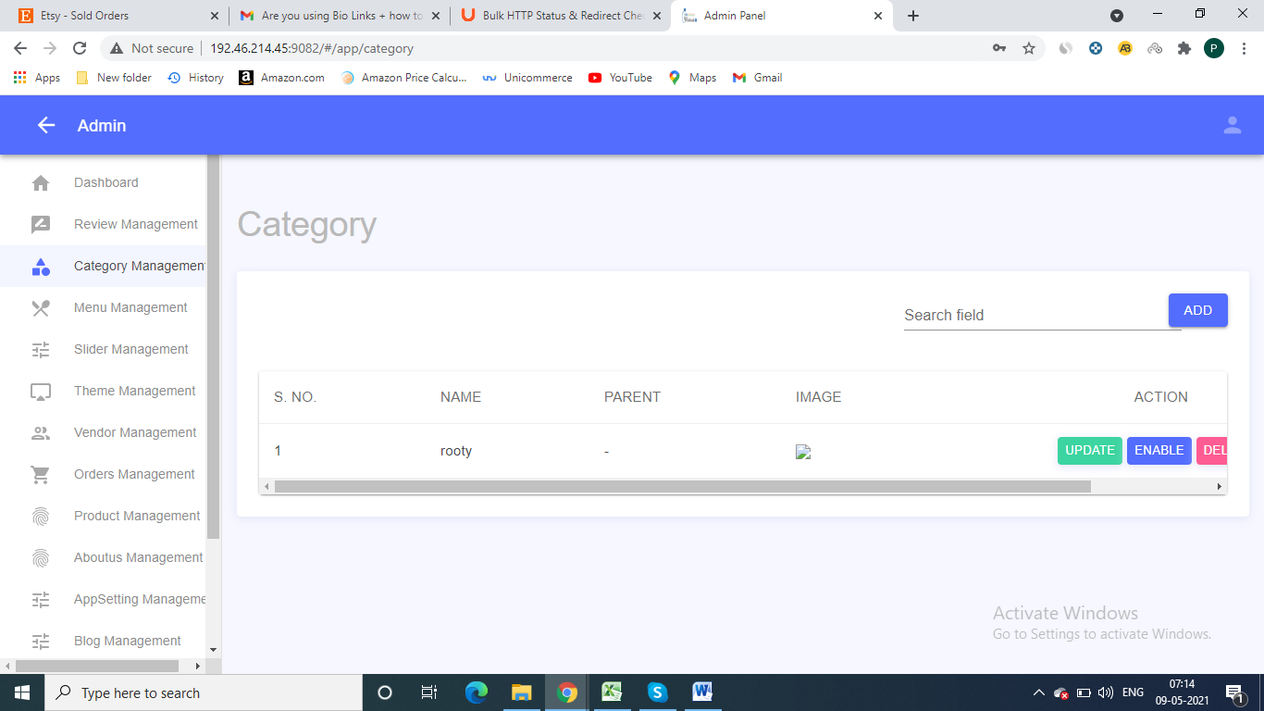

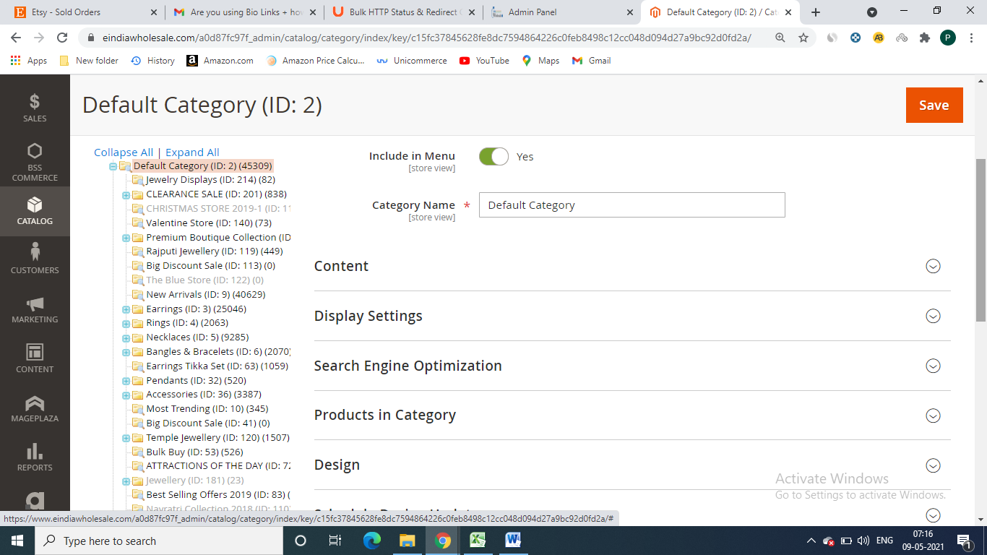

2) Slider Block – In current slider setting we have more option like slider country, description, link validity etc please check our current eindia admin panel and make according to it

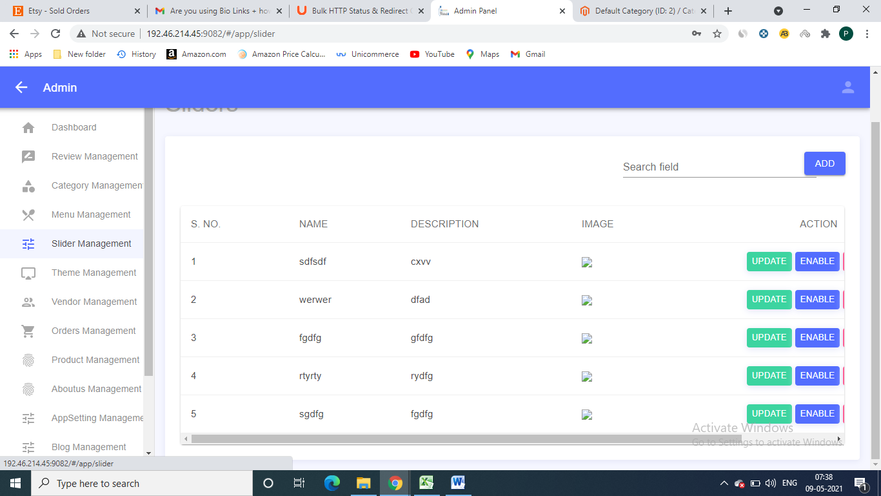

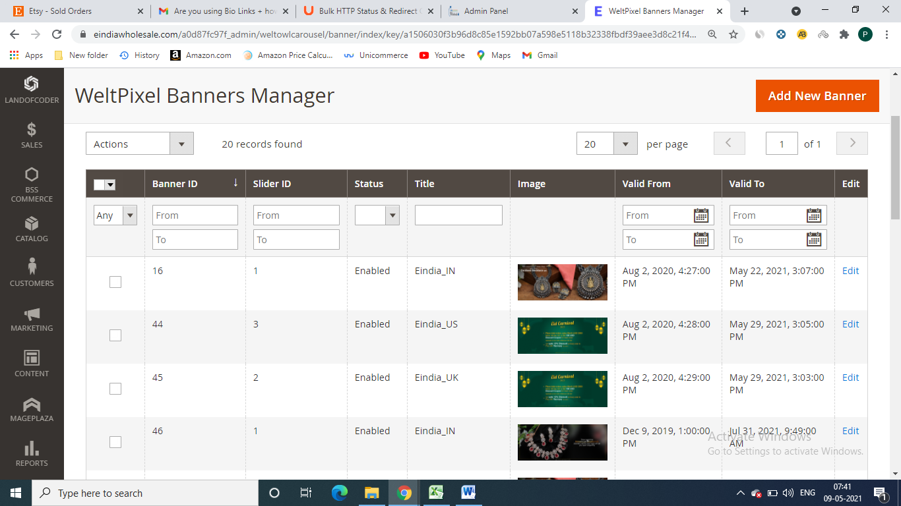

3 – Orders Block – We need Functionality in orders tab like our Current Admin panel, please check our admin panel’s order block

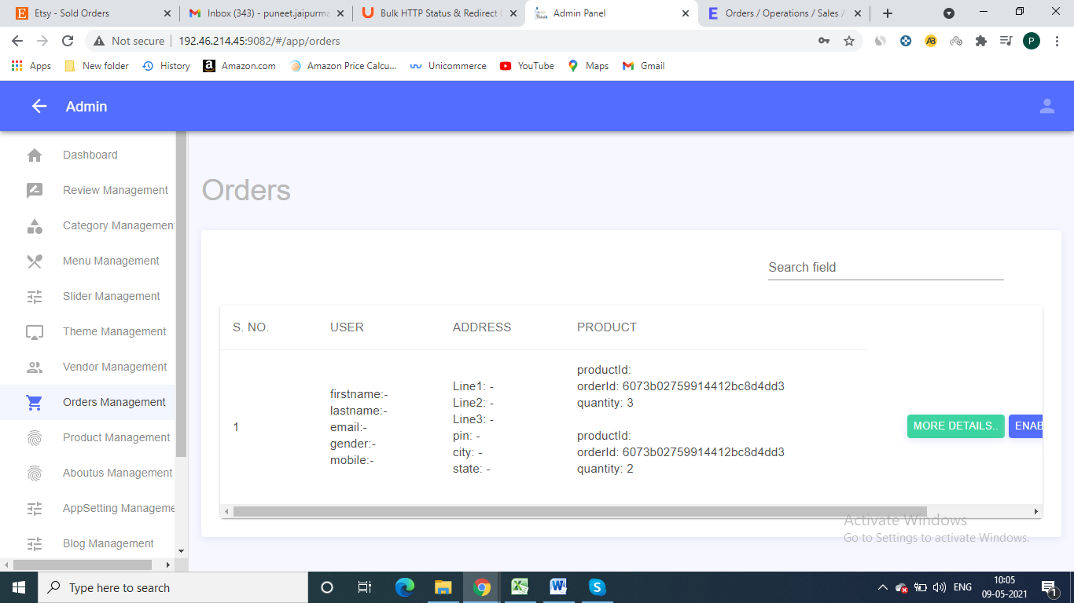

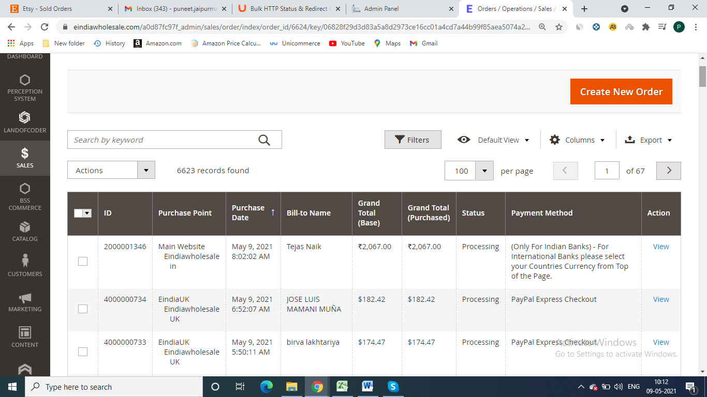

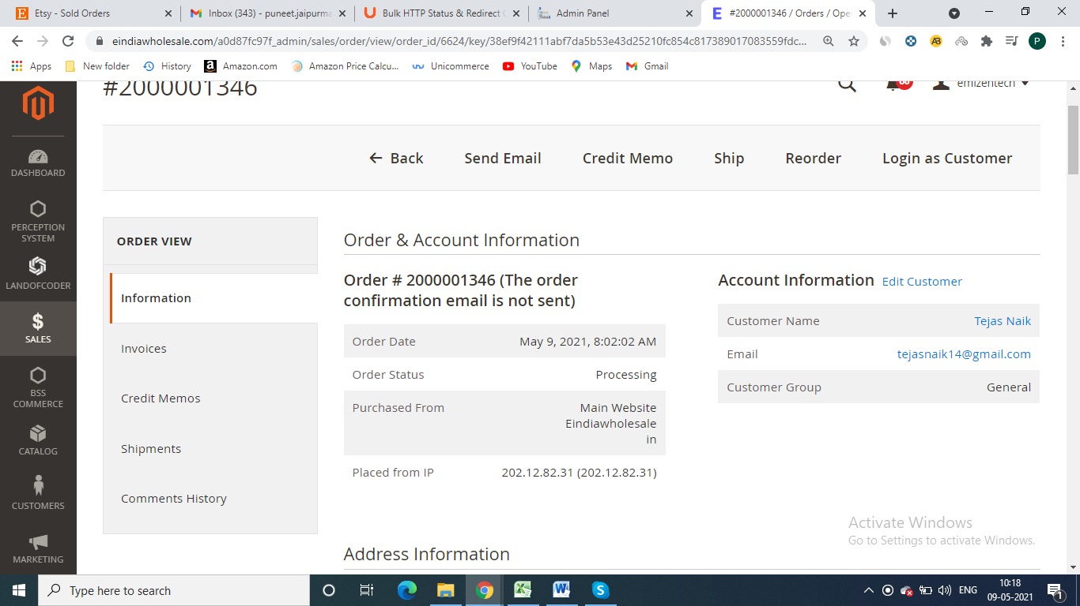

open particular order and check we have option many details and option about an order, like we have option download images of Order’s Sku , Excel Sheet of complete details about order.

4 – Product Block – there is showing only limited Option in products block, Please check our current Admin panel’s Product Block, there lot more option like Seo content, cross sell and related products and many more, We need all these necessary options in products tab

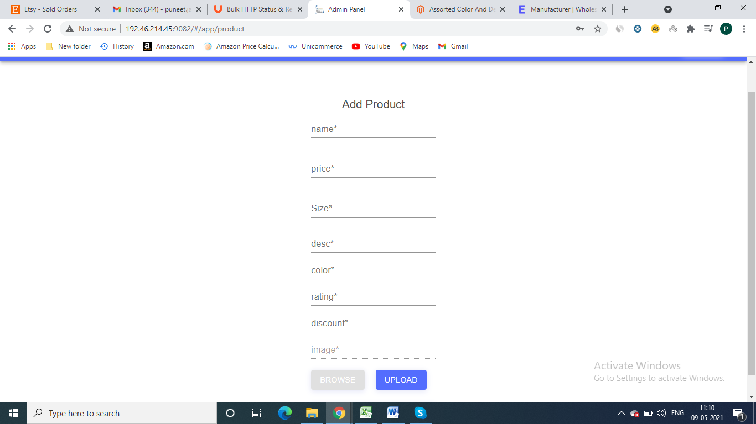

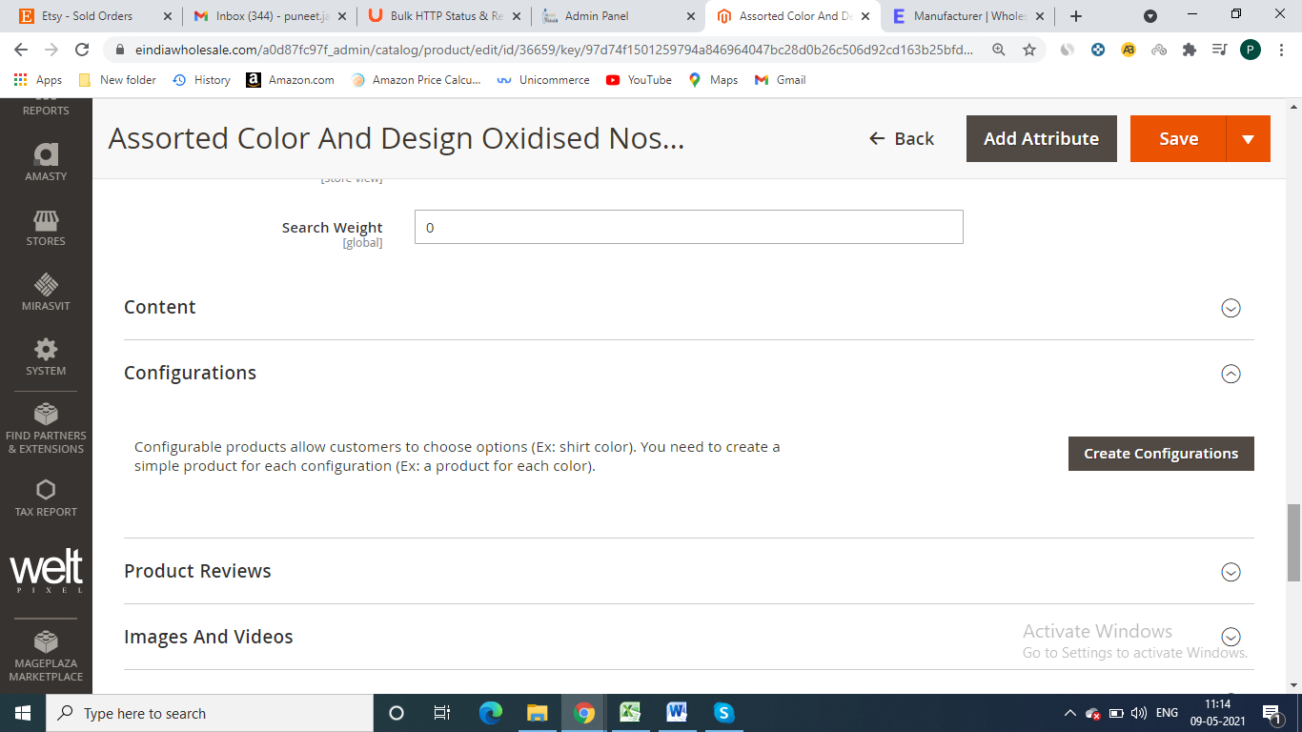

5 -